Database Lab project
Employee management system
Hasan Al Ammar

Employee Management System :
. Employees are identified by their ID and have attributes such as first name, last name, and salary
. Each employees holds one or more role characterized by a role ID, name and a description
. Employees are also associated with dependents, including relationship type, birthdate, and name
. Job titles are assigned to employees, each linked to a specific project with a project ID and name
. Employees are part of departments, defined by department ID, email, address, and a name
. They work on projects within their department as departments also controls projects, sharing the same projects attributes
. Each department is overseen by a manager, ho has a salary, manger ID, address and a name. Managers also have a supervision relationship with themselves
. Employees can also be customers, identified by customer ID, name, age, email and a phone number
. Departments are involved in selling products purchased by a customer, which have attributes such as product ID, name, a description and a price

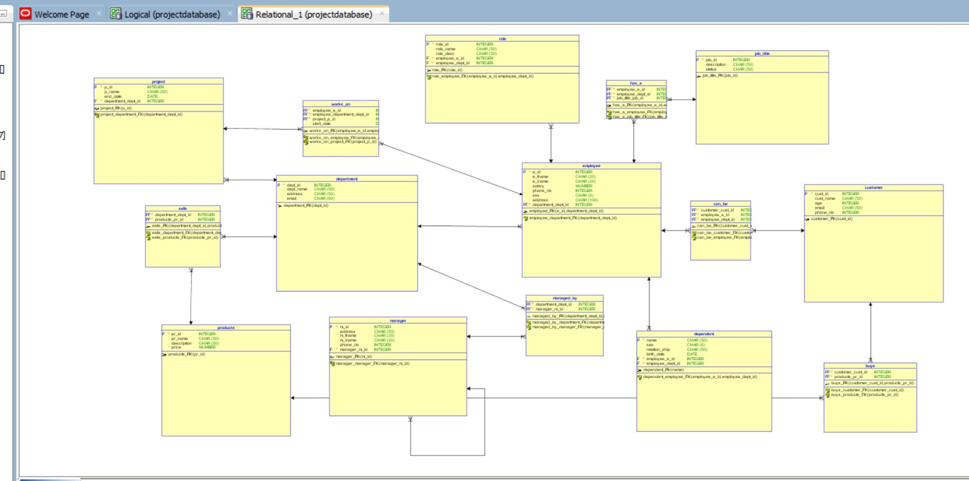

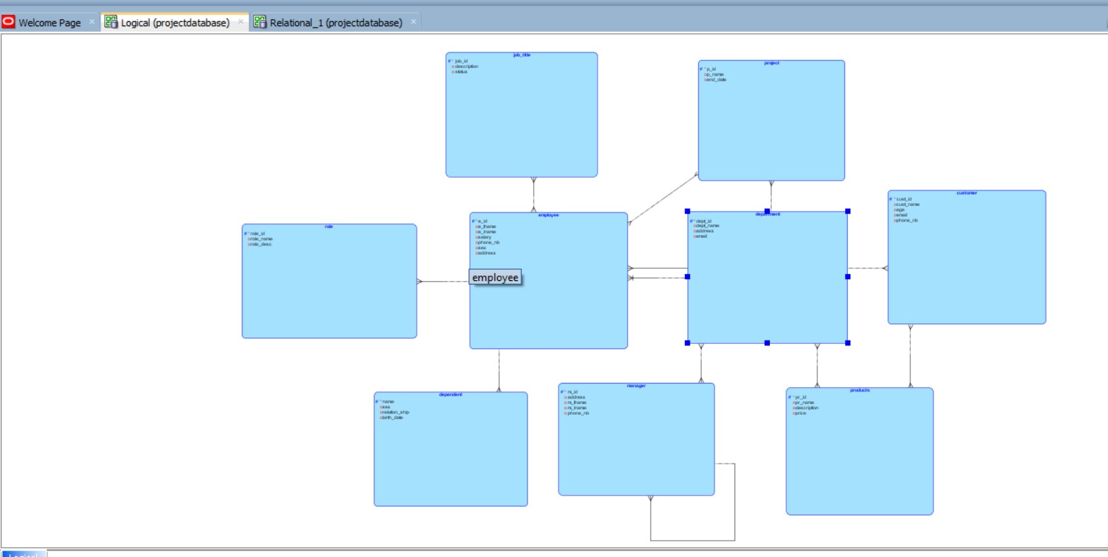

Create database new schema;
Use new schema;
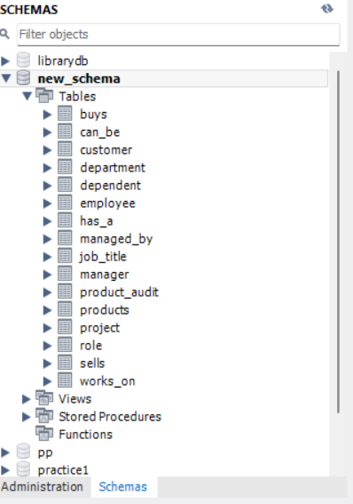

Tables :
- CREATE TABLE buys (
customer_cust_id INTEGER NOT NULL,
products_pr_id INTEGER NOT NULL );
ALTER TABLE buys ADD CONSTRAINT buys_pk PRIMARY KEY ( customer_cust_id, products_pr_id);
- CREATE TABLE customer (
cust_id INTEGER NOT NULL,
cust_name CHAR(50),
age INTEGER,
email CHAR(50),
phone_nb INTEGER
nbofprod Integer );
ALTER TABLE customer ADD CONSTRAINT customer_pk PRIMARY KEY ( cust_id );
- CREATE TABLE department (
dept_id INTEGER NOT NULL,
dept_name CHAR(50),
address CHAR(50),
email CHAR(60) );
ALTER TABLE department ADD CONSTRAINT department_pk PRIMARY KEY ( dept_id );

- CREATE TABLE dependent (
name CHAR(50) NOT NULL,
sex CHAR(6),
relation_ship CHAR(50),
birth_date DATE,
employee_e_id INTEGER NOT NULL );
ALTER TABLE dependent ADD CONSTRAINT dependent_pk PRIMARY KEY ( name );

- CREATE TABLE employee (
e_id INTEGER NOT NULL,
e_fname CHAR(20),
e_lname CHAR(20),
salary NUMBER,
phone_nb INTEGER,
sex CHAR(6),
address CHAR(100),
department_dept_id INTEGER NOT NULL );
ALTER TABLE employee ADD CONSTRAINT employee_pk PRIMARY KEY ( e_id, department_dept_id );

- CREATE TABLE has_a (
employee_e_id INTEGER NOT NULL,
job_title_job_id INTEGER NOT NULL );
ALTER TABLE has_a ADD CONSTRAINT has_a_pk PRIMARY KEY ( employee_e_id, employee_dept_id job_title_job_id );

- CREATE TABLE job_title (
job_id INTEGER NOT NULL,
description CHAR(50),
status CHAR(50) );
ALTER TABLE job_title ADD CONSTRAINT job_title_pk PRIMARY KEY ( job_id );
- CREATE TABLE managed_by (
department_dept_id INTEGER NOT NULL,
manager_m_id INTEGER NOT NULL );
ALTER TABLE managed_by ADD CONSTRAINT managed_by_pk PRIMARY KEY ( department_dept_id, manager_m_id );

- CREATE TABLE manager (
m_id INTEGER NOT NULL,
address CHAR(50),
m_fname CHAR(20),
m_lname CHAR(20),
phone_nb INTEGER,
manager_m_id INTEGER NOT NULL );
ALTER TABLE manager ADD CONSTRAINT manager_pk PRIMARY KEY ( m_id );

- CREATE TABLE products (
pr_id INTEGER NOT NULL,
pr_name CHAR(50),
description CHAR(50),
price NUMBER );
ALTER TABLE products ADD CONSTRAINT products_pk PRIMARY KEY ( pr_id );

- CREATE TABLE project (
p_id INTEGER NOT NULL,
p_name CHAR(50),
end_date DATE,
department_dept_id INTEGER NOT NULL );
ALTER TABLE project ADD CONSTRAINT project_pk PRIMARY KEY ( p_id );

- CREATE TABLE role (
role_id INTEGER NOT NULL,
role_name CHAR(50),
role_desc CHAR(50),
employee_e_id INTEGER NOT NULL,
employee_dept_id INTEGER NOT NULL );
ALTER TABLE role ADD CONSTRAINT role_pk PRIMARY KEY ( role_id );
- CREATE TABLE sells (
department_dept_id INTEGER NOT NULL,
products_pr_id INTEGER NOT NULL );
ALTER TABLE sells ADD CONSTRAINT sells_pk PRIMARY KEY ( department_dept_id, products_pr_id );

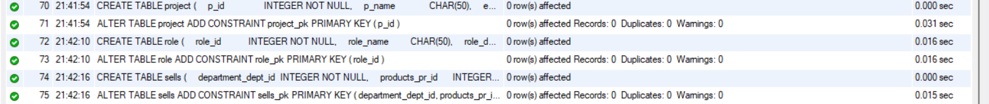

- CREATE TABLE works_on (
employee_e_id INTEGER NOT NULL,
employee_department_dept_id INTEGER NOT NULL,
project_p_id INTEGER NOT NULL,
start_date DATE );
- CREATE TABLE CAN_BE (
cust_id INTEGER NOT NULL,
e_id INTEGER NOT NULL);

ALTER TABLE works_on ADD CONSTRAINT works_on_pk PRIMARY KEY ( employee_e_id, employee_department_dept_id, project_p_id );
ALTER TABLE buys ADD CONSTRAINT buys_customer_fk FOREIGN KEY ( customer_cust_id ) REFERENCES customer ( cust_id );
ALTER TABLE buys ADD CONSTRAINT buys_products_fk FOREIGN KEY ( products_pr_id ) REFERENCES products ( pr_id );
ALTER TABLE dependent ADD CONSTRAINT dependent_employee_fk FOREIGN KEY ( employee_e_id,
employee_dept_id ) REFERENCES employee ( e_id, department_dept_id );
ALTER TABLE employee ADD CONSTRAINT employee_department_fk FOREIGN KEY ( department_dept_id ) REFERENCES department ( dept_id );
ALTER TABLE has_a ADD CONSTRAINT has_a_employee_fk FOREIGN KEY ( employee_e_id, employee_dept_id )
REFERENCES employee ( e_id, department_dept_id );
ALTER TABLE has_a ADD CONSTRAINT has_a_job_title_fk FOREIGN KEY ( job_title_job_id )
REFERENCES job_title ( job_id );
ALTER TABLE managed_by ADD CONSTRAINT managed_by_department_fk FOREIGN KEY ( department_dept_id )
REFERENCES department ( dept_id );
ALTER TABLE managed_by ADD CONSTRAINT managed_by_manager_fk FOREIGN KEY ( manager_m_id )
REFERENCES manager ( m_id );
ALTER TABLE manager ADD CONSTRAINT manager_manager_fk FOREIGN KEY ( manager_m_id )
REFERENCES manager ( m_id );
ALTER TABLE project ADD CONSTRAINT project_department_fk FOREIGN KEY ( department_dept_id )
REFERENCES department ( dept_id );
ALTER TABLE role ADD CONSTRAINT role_employee_fk FOREIGN KEY ( employee_e_id, employee_dept_id )
REFERENCES employee ( e_id, department_dept_id );
ALTER TABLE sells ADD CONSTRAINT sells_department_fk FOREIGN KEY ( department_dept_id )
REFERENCES department ( dept_id );
ALTER TABLE sells ADD CONSTRAINT sells_products_fk FOREIGN KEY ( products_pr_id )
REFERENCES products ( pr_id );
ALTER TABLE works_on ADD CONSTRAINT works_on_employee_fk FOREIGN KEY ( employee_e_id, employee_department_dept_id )
REFERENCES employee ( e_id, department_dept_id );
ALTER TABLE works_on ADD CONSTRAINT works_on_project_fk FOREIGN KEY ( project_p_id )
REFERENCES project ( p_id );

INSERTION :
- INSERT INTO employee (e_id, e_fname, e_lname, salary, phone_nb, sex, address, department_dept_id)
VALUES (1, 'hasan', 'alammar', 1233.4, 71475403, 'male', 'beirut', 555),
(2, 'sami', 'moussa', 1500, 7138889, 'male', 'beirut', 555),
(3, 'sara', 'Jaafar', 1200.5, 3098883, 'female', 'dahye', 555),
(4, 'jad', 'mousawi', 1555.22, 3888299, 'male', 'jbeil', 666),
(5, 'lara', 'hanna', 1304, 71293033, 'female', 'jounieh', 666),
(6, 'joseph', 'matta', 1500, 71444678, 'male', 'saida', 555),
(7, 'ali', 'mayladan', 1782, 3666837, 'male', 'sour', 666);

- Insert into department (dept_id,dept_name,address,email)
Values (555,”apple5”,”beirut”,” apple111@gmail.com”),
(666,”lenovo44”,”jounieh”,” lenovo344@gmail.com”),
(190,”ha”,”tripoli”,”ha233@gmail.com”);

- Insert into customer(cust_id,cust_name,age,email,phone_nb,nbofprod)
Values(121,”maher”,49,” maher1974gmail.com”, 71443405,””),
(122,”yorgo”,23,” yorgo22@gmail.com”, 03044089,””),
(123,”abbass”,35,” abbas11@gmail.com”, 7116893,””),
(124,”ali”,50,” ali345@gmail.com”, 3666837,80),
(125,”joseph”,28,” joseph9876@gmail.com”, 71444678, 29),
(126,”fatima”,18,” fatima233@gmail.com”, 3887647,9),
(127,”suzan”,17,” suzan111@gmail.com”, 71178900,5);
- Insert into products(pr_id,pr_name,description,price)
Values(1,”iphone15”,”256gb black”,1150),
(2,”laptop”,”lenovo1234”,590),
(3,”watch”,”apple watch”,230),
(4,”tv”,”Samsung 65’inches”,780);
- Insert into manager (m_id,addres,m_name,phone_nb)
Values(1,”jbeil”,”charbel”,”gemayel”,03778921),
(2,”jeih”,”mhmd”,”monzer”,71338442),
(3,”dahye”,”ali”,”mayladan”,71277283);
- Insert into managed_by (dept_id,m_id)
Values(555,1),
(555,2),
(666,3);
- Insert into project (p_id,p_name,end_date,dept_id)
Values(1,”iphone16”,”2024-09-12”,555),
(2,”ipad”,”0000-00-00”,555),
(3,"tv","2024-04-30",666),
(4,"ooo","",666);
- Insert into job_title (job_id,description,status)
Values(1,”programer”,””),
(2,”uxui”,””),
(3,”developer”,””);
- Insert into sells (dept_id,pr_id)
Values(555,1),
(555,2),
(666,3),
(666,4);
- Insert into works_on(e_id,p_id,start_date)
Values(1,1,”2023-03,03”),
(2,2,””),
(3,1,”2023-08-09”);
- Insert into has_a(e_id,dept_id,jpb_id)(1,555,1)
values (2,555,2),
(3,666,3);
- Insert into buys (cust_id,pr_id)
Values(124,1),
(124,4),
(125,4),
(126,2);
- Insert into role(role_id,role_name,role_desc, e_id)
Values(1,”programer”,” works on a programing apps”,1),
(2,”uxui designer”,”designs websites”,2),
(3,”developer”,”developes websites”,3);
- Insert into can_be(e_id,cust_id)
Values (6,125),
(7,124);
INSERT INTO buys (customer_cust_id, products_pr_id) VALUES (124, 2);
INSERT INTO employee (e_id, e_fname, e_lname, salary, phone_nb, sex, address, department_dept_id)
VALUES (10, 'John', 'Smith', -1500, 12345678, 'male', 'city', 555);

Sql questions:

1- Search for the maximum salary and the minimum salary among all employees
2- Search for the employee last names, department name ,and department number , while department number = 555
3- Finding the departments with more than 3 employees and their average salary
4- Display the number of Orders of each Customer (who has placed at least one Order)
5- Show Customers who are not employees at the same time.
6- give me a department that doesn't have any employees
7- List the names of all dependents for a specific employee.
8- Selecting all employees who have not been assigned to any project and have the lowest salary.
9- View the id and the names of all customers and employees, and the department id ,also department id= 555 and cust age>24.
10-Search for the last name and salary of employees who earn more than '', the number and salary ''.
11-show employees whose first name starts with "s".

SUB QUERIES QUESTIONS:
- Find the names of customers who bought the most expensive product.
- List the names of departments where employees have an average salary higher than 50,000.
- Get the names of employees who manage their own department.
- Find the names of products sold by departments that manage projects ending in 2025.
- Write a query to find the names of employees who have the same job title and salary as their manager

JOINS QUERIES QUESTIONS:
- List the names of all customers who bought a product, along with the product names.
- Find the total number of employees in each department.
- Find the average salary of employees in each department.
- Retrieve details of employees who work on a specific project.
- List all employees and their job titles.
VIEWS:
- View to List All Customers and Their Purchased Products
- View to Display Employee Details Along with Their Department Name
- View to Show Departments and Their Average Employee Salaries
- View to Retrieve Employees Working on Projects with Their Start Dates
- View to List Managers and the Departments They Manage
Procedures:
- This procedure inserts a new employee into the employee table.
- This procedure updates the price of a product based on its ID.
- This procedure retrieves customer details based on their ID.
- This procedure assigns an employee to a project with a specific start date.
- This procedure deletes a manager from the manager table based on their ID.

answers:

1- Select Max(salary) AS max_salary,min(salary) As min_salary
from employee;

2- SELECT e_lname, dept_name, dept_id
FROM employee, department
WHERE e.dept_id = d.dept_id AND dept_id = 555;

3- SELECT dept_id, AVG(salary) AS avg_salary
FROM employees
GROUP BY dept_id
HAVING COUNT(*) > 5;

4- select count(*)nbofprod,cust_id
from customer
groupby cust_id;

5- SELECT *
FROM customer
WHERE cust_id NOT IN (SELECT e_id FROM employee);

6- SELECT dept_name, dept_id
FROM department
WHERE dept_id NOT IN (SELECT dept_id FROM employee);

7- SELECT d.name, d.relation_ship, d.birth_date
FROM dependent d
WHERE d.employee_e_id = <EMPLOYEE_ID>;

8- SELECT *
FROM employee e
WHERE e_id NOT IN (SELECT DISTINCT e_id FROM works_on)
AND salary = (SELECT MIN(salary) FROM employee );

9- SELECT e_id, e_fname, dept_id
FROM employee
WHERE dept_id = 666
UNION
SELECT cust_id, cust_name
FROM customer
WHERE age > 24;

10- SELECT e1.e_fname,e1.salary,e2.e_fname,e2.salary
from employee e1,employee e2
where e1.salary>e2.salary and e2.e_fname="sami";

11-SELECT *
FROM employee
WHERE e_fname LIKE 's%';

12- DELETE FROM manager WHERE m_id = 1;
13- UPDATE products SET price = 1200 WHERE pr_id = 1;
14- SELECT * FROM product_audit;
DELETE FROM department WHERE dept_id = 555;

SUB QUERIES ANSWERS:

15- SELECT cust_name
FROM customer
WHERE cust_id IN ( SELECT customer_cust_id FROM buys
WHERE products_pr_id = ( SELECT pr_id FROM products
WHERE price = (SELECT MAX(price) FROM products) ) );

16- SELECT dept_name
FROM department
WHERE dept_id IN (
SELECT department_dept_id
FROM employee
GROUP BY department_dept_id
HAVING AVG(salary) > 50000);

17- SELECT e_fname, e_lname
FROM employee
WHERE e_id IN (
SELECT manager_m_id
FROM managed_by
WHERE department_dept_id = (
SELECT department_dept_id
FROM employee
WHERE e_id = manager_m_id )
);

18- SELECT pr_name
FROM products
WHERE pr_id IN (
SELECT products_pr_id
FROM sells
WHERE department_dept_id IN (
SELECT department_dept_id
FROM project
WHERE end_date BETWEEN '2024-01-01' AND '2025-12-31'));

19- SELECT e1.lname AS employee_name
FROM employees e1
WHERE (e1.job_title, e1.salary) IN
(SELECT e2.job_title, e2.salary
FROM employees e2
WHERE e2.employee_id = e1.manager_id);

JOINS QUERIES ANSWERS:

20- SELECT c.cust_name, p.pr_name
FROM customer c
JOIN buys b ON c.cust_id = b.customer_cust_id
JOIN products p ON b.products_pr_id = p.pr_id;

21- SELECT d.dept_name, COUNT(e.e_id) AS total_employees
FROM department d
JOIN employee e ON d.dept_id = e.department_dept_id
GROUP BY d.dept_name;

22- SELECT d.dept_name, AVG(e.salary) AS avg_salary
FROM department d
JOIN employee e ON d.dept_id = e.department_dept_id
GROUP BY d.dept_name;

23- SELECT e.e_fname, e.e_lname, j.description AS job_title
FROM employee e
JOIN has_a h ON e.e_id = h.employee_e_id
JOIN job_title j ON h.job_title_job_id = j.job_id;

VIEWS ANSWERS :

25-CREATE VIEW CustomerPurchases AS
SELECT c.cust_id, c.cust_name, p.pr_name, p.price
FROM customer c
JOIN buys b ON c.cust_id = b.customer_cust_id
JOIN products p ON b.products_pr_id = p.pr_id;

26- CREATE VIEW EmployeeDetails AS
SELECT e.e_id, e.e_fname, e.e_lname, e.salary, d.dept_name
FROM employee e
JOIN department d ON e.department_dept_id = d.dept_id;

27- CREATE VIEW DepartmentAverageSalary AS
SELECT d.dept_name, AVG(e.salary) AS avg_salary
FROM department d
JOIN employee e ON d.dept_id = e.department_dept_id
GROUP BY d.dept_name;

28- CREATE VIEW EmployeeProjectDetails AS
SELECT e.e_id, e.e_fname, e.e_lname, p.p_name, w.start_date
FROM employee e
JOIN works_on w ON e.e_id = w.employee_e_id AND e.department_dept_id = w.employee_department_dept_id
JOIN project p ON w.project_p_id = p.p_id;

29- CREATE VIEW ManagerDepartmentDetails AS
SELECT m.m_id, m.m_fname, m.m_lname, d.dept_name
FROM manager m
JOIN managed_by mb ON m.m_id = mb.manager_m_id
JOIN department d ON mb.department_dept_id = d.dept_id;

Procedures:

30- DELIMITER //
CREATE PROCEDURE AddEmployee(
IN emp_id INT,
IN emp_fname CHAR(20),
IN emp_lname CHAR(20),
IN emp_salary DECIMAL(10,2),
IN emp_phone_nb INT,
IN emp_sex CHAR(6),
IN emp_address CHAR(100),
IN emp_dept_id INT)
BEGIN
INSERT INTO employee (e_id, e_fname, e_lname, salary, phone_nb, sex, address, department_dept_id) VALUES (emp_id, emp_fname, emp_lname, emp_salary, emp_phone_nb, emp_sex, emp_address, emp_dept_id);
END //
DELIMITER ;
CALL AddEmployee(8, 'John', 'Doe', 1800.50, 71456789, 'male', 'tripoli', 190);

31-DELIMITER //
CREATE PROCEDURE UpdateProductPrice(
IN prod_id INT,
IN new_price DECIMAL(10,2))
BEGIN
UPDATE products
SET price = new_price
WHERE pr_id = prod_id;
END //
DELIMITER ;
CALL UpdateProductPrice(1, 1200.00);

32-DELIMITER //
CREATE PROCEDURE GetCustomerDetails(
IN cust_id INT)
BEGIN
SELECT cust_id, cust_name, age, email, phone_nb, nbofprod
FROM customer
WHERE cust_id = cust_id;
END //
DELIMITER ;
CALL GetCustomerDetails(124);

33-DELIMITER //
CREATE PROCEDURE AssignEmployeeToProject(
IN emp_id INT,
IN proj_id INT,
IN start_date DATE)
BEGIN
INSERT INTO works_on (employee_e_id, project_p_id, start_date)
VALUES (emp_id, proj_id, start_date);
END //
DELIMITER ;
CALL AssignEmployeeToProject(3, 2, '2024-01-15');

34- DELIMITER //
CREATE PROCEDURE DeleteManager(
IN mgr_id INT)
BEGIN
DELETE FROM manager
WHERE m_id = mgr_id;
END //
DELIMITER ;
CALL DeleteManager(2);
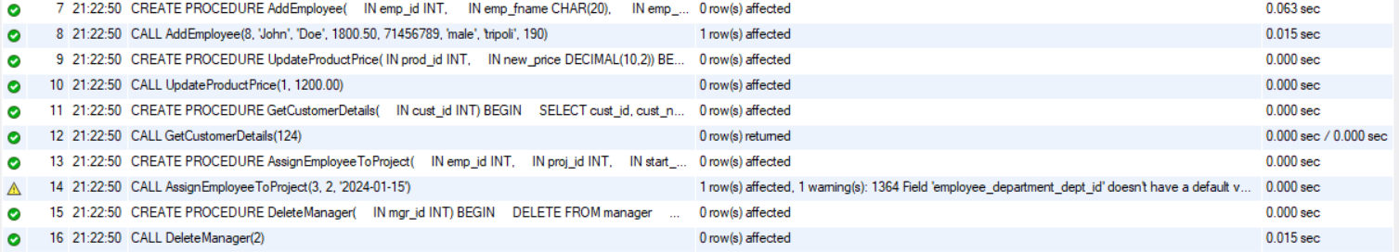

Triggers:

1- DELIMITER //
CREATE TRIGGER UpdateCustomerNbofProd
AFTER INSERT ON buys
FOR EACH ROW
BEGIN
UPDATE customer
SET nbofprod = nbofprod + 1
WHERE cust_id = NEW.customer_cust_id;
END //
DELIMITER ;

2- DELIMITER //
CREATE TRIGGER PreventNegativeSalary
BEFORE INSERT ON employee
FOR EACH ROW
BEGIN
IF NEW.salary < 0 THEN
SIGNAL SQLSTATE '45000'
SET MESSAGE_TEXT = 'Salary cannot be negative.';
END IF;
END //
DELIMITER ;

3- DELIMITER //
CREATE TRIGGER DeleteManagedByOnManagerDelete
AFTER DELETE ON manager
FOR EACH ROW
BEGIN
DELETE FROM managed_by
WHERE manager_m_id = OLD.m_id;
END //
DELIMITER ;

4- DELIMITER //
CREATE TRIGGER AuditProductChanges
AFTER UPDATE ON products
FOR EACH ROW
BEGIN
INSERT INTO product_audit (pr_id, old_price, new_price, change_date)
VALUES (OLD.pr_id, OLD.price, NEW.price, NOW());
END //
DELIMITER ;

CREATE TABLE product_audit ( pr_id INT, old_price DECIMAL(10,2), new_price DECIMAL(10,2), change_date DATETIME );

5- DELIMITER //
CREATE TRIGGER RestrictDepartmentDeletion
BEFORE DELETE ON department
FOR EACH ROW
BEGIN
IF EXISTS (SELECT 1 FROM project WHERE department_dept_id = OLD.dept_id) THEN
SIGNAL SQLSTATE '45000'
SET MESSAGE_TEXT = 'Cannot delete a department with associated projects.';
END IF;
END //
DELIMITER ;
